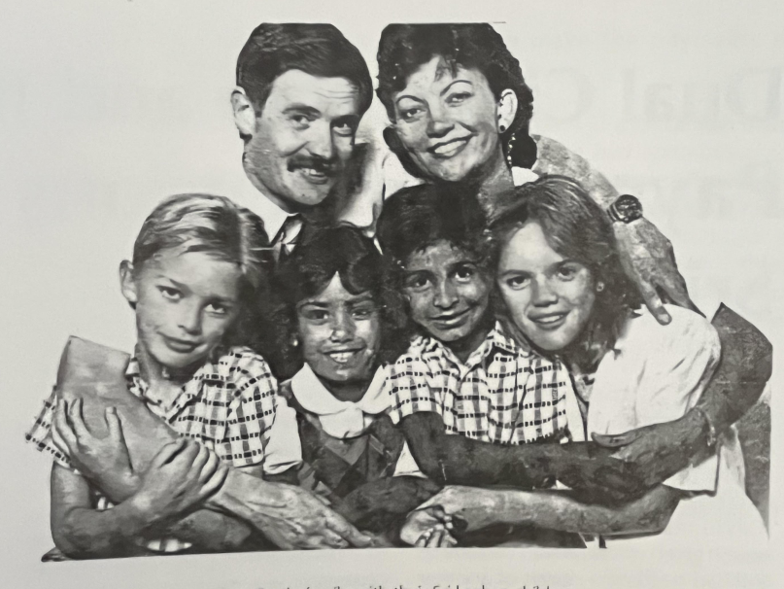
The Castle family with their Sri lankan children

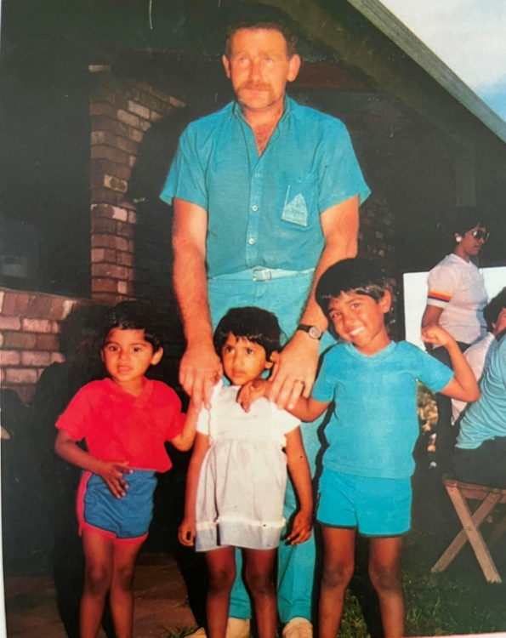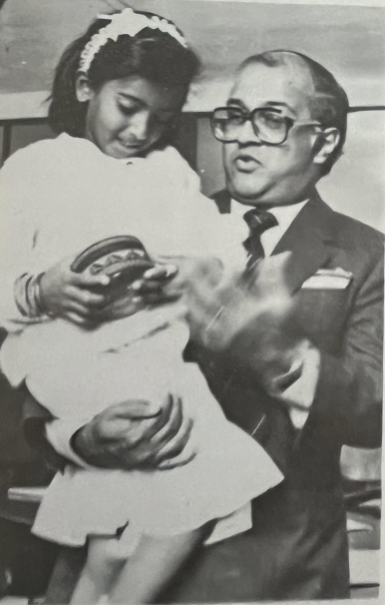
Trevor Longhridge with his three Sri Lankan children
Chrishanthi, daughter of Terry and Val Crooks of Goulburn with the High Commissioner, Dr Weerassoria

