http://thuppahi.wordpress.com/2014/09/15/tamil-person-and-state-pictorial-images-listed/

http://thuppahi.wordpress.com/2014/09/15/tamil-person-and-state-pictorial-images-listed/
September 15, 2014 · 2:04 am | Edit

Tamil Person and State: Pictorial … Images Listed
Michael Roberts

Contents
Acknowledgements v
Preface vii
List of Pictorial Items xvii
Abbreviations xxxiii
Prologue xxxv

Visual Imagery within Political Struggles and Manoeuvres …. pp. 1-44

Photographs …. pp. 45-208

Postface: BBC Blind …. pp. 209-29
Bibliography …. pp. 230-51
List of Appendices … pp. 252-92
Appendix I: Media Personnel transported to battlefront by Min-of Defence … pp. 252-63
Appendix II: Estimates of the Death Toll among the Fighting Forces of the LTTE and Government of Sri Lanka …. pp. 264-66
Appendix III: NGOs providing Relief at the Mānik Farm Detention Centres …. pp. 267-70
Appendix IV: US Ambassador Robert Blake’s Secret Despatch, 19 March 2009…. pp. 271-72
Appendices V: Inaugural Meeting of the Ilankai Tamil Arasu Kadchi, Colombo, 18 December 1949 … with Presidential Address by SJV Chelvanayagam …. pp. 273

List of Pictorial Items
Illustrations for introductory chapter
A. Ecstasy and a karate kick before the kill, 24/25 July 1983
B.A killing victim at Varanāsi, 23 December 1992
C. A Muslim shot by police during Seelampur riots, Delhi, 1992
D. Hindu mob assembled at night during Bhagalpur pogrom, 28 October 1990
E. Massive crowd of White Americans assembles to watch the lynching of a Black American, Henry Smith, at Paris, Texas, 1 February 1896
F. A case of torturing: two interpretations
F1: The image and its tale in The Cage
F2. The unmodified image discovered by GSL sources … with tell-tale slippers suggestive of Tiger troops
G. DiManno’s slanted pictorial pick: a weak attempt to fool the public about the scenario of the Last Redoubt
H1, 2. LTTE video of auxiliary mobilisation for belligerent activity
I. David Cameron’s visit to Jaffna draws world attention to the anguish of kin seeking the “missing”
J. Tamils greet Cameron with demonstration depicting photographs of missing kin
K. Tamil women seeking their kin in public expressions of grief and anger
L. Tamils abandon Thamilīlam and walk through jungle at night to safety of Army terrain, February 2009
M1, 2. Mobilisation in search of the “disappeared” kin, 2012 and 2013
******************************
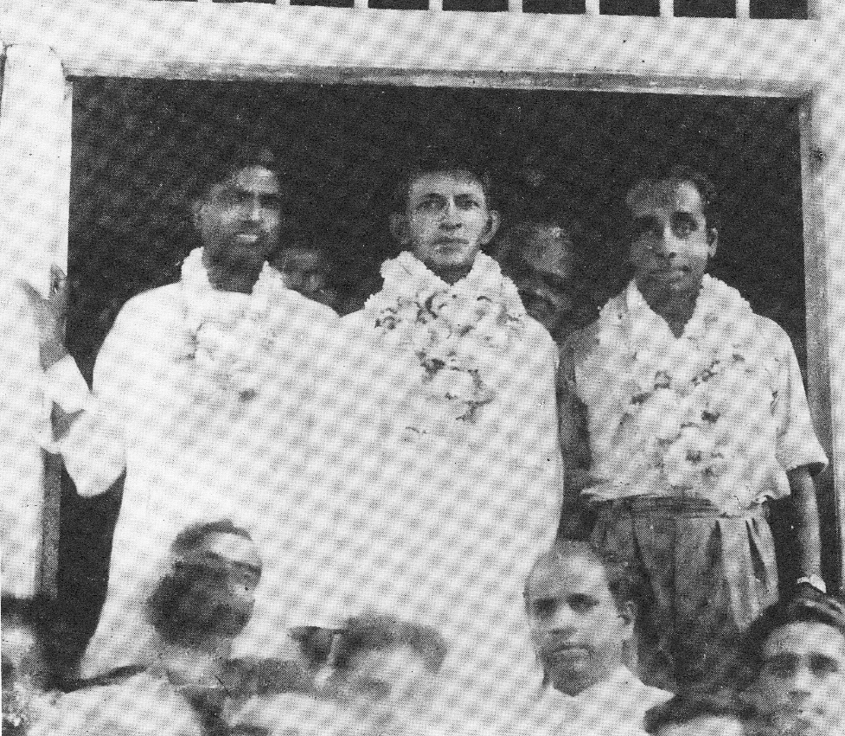 GG Ponnambalam, SJV Chelvanayakam and C Vanniasingham, of the Tamil Congress in 1947
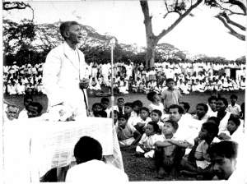 Chelvanayakam campaigning
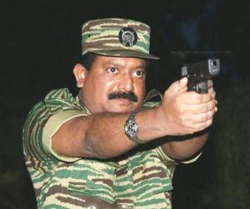 the talaivar Pirapaharan with revolver

Main Body of Images
1. GG Ponnambalam, SJV Chelvanāyakam and C Vanniasingham, the triumvirate of the Tamil Congress, just after the General Election results were announced on 1st September 1947
2a. Sir John Kotelāwala with Tamil supporters
2b. SJV Chelvanāyakam addresses a crowd at Valvettithurai
3a, b. Tamil satyagrāha protests on Galle Face Green and violent Sinhala reactions by word and fist
4. Bandāranaike and Chelvanāyakam seal the BC Pact with a handshake, 26 July 1957
5a. A bhikkhu castigates Prime Minister Bandāranaike at Rosmead Place
5b. Another bhikkhu rouses people against the BC Pact
6. Mrs Wijewardene and bhikkhus in protest outside PM’s residence
7. Sinhalese people assaulting and ridiculing a Tamil person in Colombo during the mini-pogrom of mid-1958
8a, b. Riot and arson scenes, 1958
8c. A government official listens to a cluster of Tamil refugees
9a, b. Tamil satyagrāhi increase pressure in north & east and face state violence, 1960-61
8. Ponnuthurai Sivakumāran of Urimpurai: liberation hero
11a, b. Onfield Tamil protests at Kennington Oval, London, 11 June 1975
12. Four early Tiger leaders of commanding capacity
13. Young Pirapāharan and his fascination with weaponry
14a. Enjoying their assaults: riotous mob at Borella reveal exhilaration, night of 24/25th July 1983
14b. A scene from Borella … afterwards
15. The other militant forces, 1980s
15a. TELO calendar poster
15b. A clutch of EPDP guerrillas
16. Uneasy cooperation under Indian pressure, 1985: four fighting Tamil leaders
17. Tiger commanders at Sirimalai camp in north India, 1984
18a. Pirapāharan in conversation with MGR, February 1985
18b. Pirapāharan as Che Guevera
19a. The northern shoreline as militants’ lifeline
19b. Tiger “boys” on guard, late 1980s 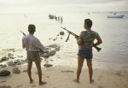
18. The Vadamarachchi Operation launched by the Sri Lankan Army on 26 May 1987 …. and its commanders
21a, b. Indian interventions: virulent protests from legal fraternity and other groups in Lanka, mid-1987
22. Rajiv Gandhi and JR Jayewardene sign the Indo-Lanka Accord, 29 July 1987
23. Kumarappa (LTTE Commander, Vavuniya District) shaking hands with General Harikat Singh of the IPKF with Mahattayā (Tiger second in command) looking on
24.The LTTE directorate on the platform at Sudumalai, 4 August 1987
25. Tamils assembled en masse at Sudumalai Ammān Kovil grounds to hear Pirapāharan speak, 4 August 1987
26a, b. Thilīpan fasts unto death in protest against the IPKF policy and presence, 15-26 September 1987
27a. Indian troops on guard during their war, 1987-89
27b. Indian troops in waiting
28. Embedded with the ‘enemy’– Shyam Tekwani’s striking camerawork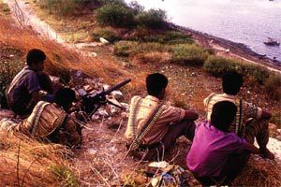
28a. Tigers on guard along shoreline
28b. Tigers covering internal movement of Tamil refugees
28c. A young Tiger lad heads for duty with vipoothi and kuppi as protection
29. Uyirāyutham: life gifted for cause. Tiger fighters relaxing in camp display their kuppi, the cyanide capsules they were committed to bite when facing threat of capture
30. Adele & Anton Bālasingham in the LTTE command area
31. Six martyrs from the early decades of the Tamil liberation struggle
32a. Pirapāharan pays homage to the Black Tigers, 5 July 2005
32b, c. Flame of Sacrifice being lit at the Black Tiger ceremony at Sampur, 5 July 2003 with Pirapāharan respectfully commemorating the māvīvar at another ceremony (no details)
33. Calendar poster from 2004 depicting the pre-1983 Tiger māvirār
34a. Black Tigers marching, date uncertain
34b. Black Tigers pay homage to their fallen at Sampur in Muttur East, 5 July 2003 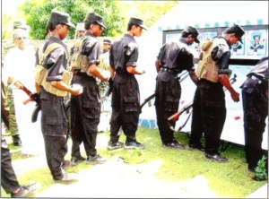
35a. Pirapāharan has a meal with Black Tigers prior to their suicide mission
35b. Pirapāharan presented with the Tiger squad before their suicidal commando mission at Anuradhapura airbase, 22 October 2007
36a. Induction ceremony after training: a Tiger commander ‘anoints’ a new recruit with a kuppi
36b. Tamil Tigresses on patrol
37a. A female platoon of the LTTE in parade formation
37b. Tamil Tigresses
38a. Sea Tigers load a fast attacking craft
38b. Sea Tiger fast attack craft with shallow draft ferries people
39. Pirapāharan, Anton, Shankar and KP in the Vanni, n. d.
40. The LTTE’s massacre of Muslims at Kattankudy Mosque in the Eastern Province is marked by this poignant image of fellow Muslims bearing their dead away
41a. Civilians in Welikanda area massacred by the LTTE during Eelam War IV, 29 May 2006
41b. Kin folk grieve their dead after an LTTE assault on civilians in the frontier zone, n. d.
42a, b. LTTE attack on Central Bank in the heart of Colombo, 31 January 1996
43. Mahesweri School in Batticaloa decked out with photographs of 250 māvīrar enveloped in a blaze of light and colour evocative of ārati, November 2004
44a. Tuyilam illam at Kopay, Jaffna Peninsula readied for Māvīrar Day, 27 November 2004
44b. A kinsman pays homage to a māvīrar at Kopay, n. d.
45a. Flagpole encompassed by jasmine flowers at the tuyilam illam at Vavuniya
45b. Gravestones encompassed as kin folk grieve and pay homage to their māvirar at a tuyilam illam 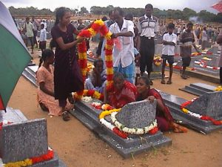
46a, b. Māvīrar commemoration shed at Tirunelvely campus, Jaffna University, November 2004
47. Female māvīrar surrounded by tropes of abundance at Valvettithurai commemoration shed, 2004
48. Bodies that fight on: the implicit message inscribed through the cenotaph at Kilinochchi
49a. Balraj, an exemplary fighter & commander
49b. Balraj at work
49c. Balraj and his troops celebrate the capture of a battle tank at Ithaavil
50. Senior LTTE commanders line up, c. 2004
51. LTTE ingenuity and its conventional military strength
52. Māvīrar Nāl in Chicago, 2004… and the “Tamil homelands”
53a, b. Pongu Thāmil pageant in Geneva, summer 2003
54. Pirapāharan as regenerative force for the Tamil people
55. Tiger salute by TNA politicians at Pongu Thamil gathering at Trincomalee, March 2002
56a, b. Mass support for Thamilīlam at Pongu Thamil rally at Trincomalee, 19 March 2002
57a, b. Performative pageantry evoking LTTE claims among the Tamil diaspora at Pongu Thāmil event
58. The LTTE emblem of karthigai embodied in a stage pageant in Germany
59. Pirapāharan signs the ceasefire agreement, 21 February 2002
60a. Pirapāharan’s father’s house in Valvettithurai
60b. Pirapāharan, Adele and Anton mount the podium for the LTTE media event at Kilinochchi, 10 April 2002
61a, b, c. Thāmilīlam as nation state: LTTE media event, 10 April 2002
62a, b. Mākkal Padai: the LTTE’s mobilisation of the Tamil people as militia from late 2004
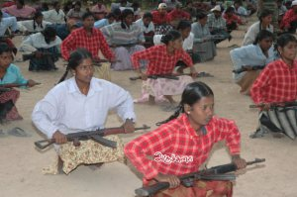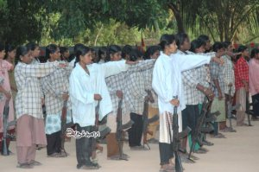
63. Peoples’ militia in and for Thamilīlam
64a, b, c. Weapons training for the militia
65a, b. Sri Lankan Army closes in on the last LTTE stronghold in the east at Thoppigala
66. Capture of Thoppigala circa 14 August 2007 marks LTTE’s loss of power in the Eastern Province
67. Map of Thamilīlam and forward defence lines: late 2007 stalemate
68. Sinking of the Seishin, a LTTE arms-carrying cargo ship, 10 September 2007
69a. Map showing how Sri Lankan Navy ranged far & wide into Indian Ocean to destroy LTTE supply ships, September 2007
69b. “Matsushima” incapacitated, 7 October 2007
69. Waveriders and Arrow boats of SL Navy’s Special Boat Squadron
71a, b. Sri Lankan Army makes inroads into Thamilīlam territory in the Northern Vanni from c. April 2008
72a, b. Sri Lankan Army advances, 2008
73a, b. Bund, ditch & water defence system perfected by the LTTE to thwart the SL Army
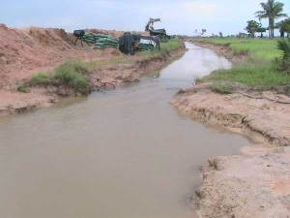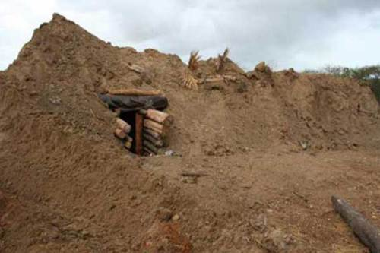
74. Embankment and ditch defence system: more illustrations
75a, b, c. LTTE bases topple as SL Army advances northwards on the western coast and then eastwards
76a, b, c. The LTTE loses ground through 2008 and retreats eastwards
77. Map of the war fronts, 23 December 2008
78. Situation map, 6 January 2009
79. Situation map, 22 January 2009
80a, b. Multiple displacements for the Tamil citizens of Thamilīlam in the Vanni, mid-2008-February 2009
81. Displaced discomfort in the Vanni Pocket imposed by the LTTE
82. On the move again and again – the fate of the corralled Tamil citizens of Thāmilīlam, 2009
83a, b. Maps of the war front within the “Vanni Pocket” on 22 February 2009
84a, b. Bursting shells among civilian dwellings
85a, b, c. Wounded people and medical responses
86a, b. Outpourings of grief as people die or are injured
87a. Puthumaathalaan makeshift hospital, 13 February 2009
87b. Civilian dead at LTTE mortuary, 1 January 2009
88a. Wounded are brought for treatment
88b, c. Lamentations for dead kin
89. Map of the “Vanni Pocket” in early 2009 – as presented by Ban Ki-Moon’s UN Panel
90a. Map of the war front within the “Vanni Pocket,” 20 March 2009
90b. Graphic map of the war front, 2 March 2009
91. A tent city in the Last Redoubt 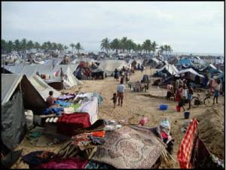
92a, b. Congestion along the main road at Ampalavanpokkanai in the northern sector of the Last Redoubt, 29 March and 16 April 2009
93a. Queues for food and water as daily routine in the Last Redoubt
93b. Children queue for essentials
94a, b. Medivac operations from ICRC & SL Navy rescue some of the injured, plus others, from the Last Redoubt, February – 9 May 2009
95. Tamil people evacuated by sea: ICRC and SL Navy
96a, b, c. The SL Navy to the rescue
97. Medical disaster management: forward planning by Tamil doctors & Ministry of Health
98a, b, c. Tamils who fled by sea and the SL Navy
99a, b, c. SL Army successes in the last stages of the war & its terrain
100a, b. Tiger dead after Puthukkudiyirippu was captured
101. Analytic graphic map revealing how SL Army brigades penetrated the Last Redoubt, 19-22 April 2009
102. “Wretched of the earth break free of bondage” – Jeyaraj
103a, b. Abandoning the LTTE 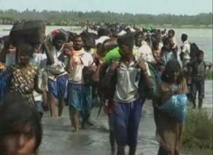
104a, b. Other Tamils move south into Vellamullaivaikkal in the Last Redoubt
105a, b. Congestion in the southern reaches of the Last Redoubt
106. BBC’s twist on this shift in settlement pattern: a slant reiterated in 2013
107a, b. A congealed mass of dwellings, people & traffic around the main road, May 2009
108a, b, c. Shelling impact captured by LTTE sources
109a, b, c. Protective foxholes & make-do sandbags among civilian ‘dwellings’… Mullaivaikkal area
110a, b. Bunkers in Last Redoubt camouflaged by shack and truck
111a, b. Making do: basic shelter & life under tarpaulin
112a, b. Queues … and more queues
113a, b. LTTE paradox: sustaining life while endangering life
114a. An Out Patients Department at medical work
114b, c. LTTE organisational capacities: keeping administrative track
115a, b. Making do: catch fish, sell goods
116. Graphic map of the shrunken “Last Redoubt” of the LTTE, 7 May 2009
117a. Mortar pits trailer and bulldozer identified amidst the debris in the Last Redoubt
117b. Heavy mortar, LTTE
118a, b. The LTTE’s last stand in May 2009 & desperate propaganda
119a, b. Mullaivaikkal hospital said to be under attack, 12 May 2009
120. Alleged hospital attacks as incendiary propaganda
121a, b, c. Mullaivaikkal hospital mostly intact: a lie revealed in mid-May 2009
122. Mortar crater and trickery: LTTE ‘evidence’ of shelling impact
123. Deciphering LTTE subterfuge: a re-working that identifies a mortar crater
124. Satellite imagery analysed
125a, b. Re-analysis: MBR shell impact in aerial picture identified by Citizen Silva
126a. The final squeeze: map of Thamilīlam and its death throes, 15 May 2009
126b. The final squeeze
127a. LTTE blow their munitions, 15 May 2009
127b, c. Buried LTTE artillery within Last Redoubt unearthed by cyclone, 31 October 2013
128a, b, c, d. The trapped Tamil people stream out ….. as IDPs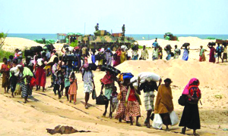
129a, b. The second exodus: Yatawara’s pictorial ‘strikes’
130. Escape, death and killing in the last week, mid-May 2009
131a, b. Pirapāharan’s last refuge
132a. Pirapāharan identified
132b. Pirapāharan’s LTTE identity card recovered and displayed
133a. The key architects of victory shake hands in balmy mood
133b. Sri Lankans celebrate
134a. Tamil demonstrations at University Avenue, Toronto. late April 2009 onwards
134b. Rallies in London
135a, b. Tamil agitation at fever pitch, April-May 2009
136. SL Army struggles to cope with Tamil survivors at the rear of the battlefield
137a, b. Aid and care extended to most survivors
138a, b. Water at a premium
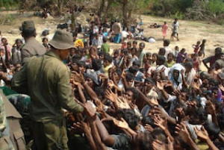
139a, b. Relief and logistical problems at the battlefront-rear
140. Transporting a mass of IDPs
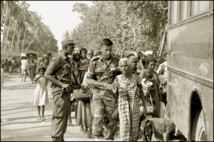
141a, b. The Sewalanka feeding operation, Omanthai, mid-May 2009
142. Zones 1 and 2 in Mānik Farm being prepared on the run in late April 2009
143. A field hospital being set up at Mānik Farm, late April 2009
144. NGOs at the heart of the welfare effort 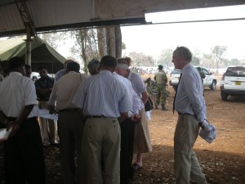
145a, b, c. Scenes from Mānik Farm in April-May 2009
146a, b, c. Hostile reportage re detention centres: barbed wire & “razor wire” imagery deployed widely
147. Stark images deployed
148a, b. Food packets distributed to IDPs as they arrived in the zonal camps, May 2009
149. Communal kitchens run by inmates & aid workers 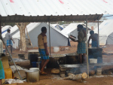
150a, b. Medical clinics in open-air and on the run: April-May, 2009
151a, b. Medical clinics on the run: April-May, 2009 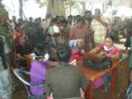
152. Daily deaths chartered as spot graph, late May 2009-November 2009
153a, b. Schooling facilities set up at Mānik Farm
154a, b. Street drama and a dance performance as recreation at the IDP camps, July 2009
155a. A ward at one of the medical centres within a field hospital at Mānik Farm, July 2009
155b. Children painting and drawing at a psycho-social centre, Mānik Farm, July 2009
156a. A street scene, probably at Kadirgamar Camp, July 2009
156b. Vegetable plots, Kadirgamar Camp, July 2009
157a, b, c. Shops within the precincts of camps at Mānik Farm, 2009
158. Telephone facility in use, Mānik Farm, 2009
159. UNICEF charts the improvement in nutritional levels at the IDP camps
160. Birthday cake & sweet essences offered in homage to talaivar Pirapāharan on 26 November 2012
161a, b, c. Tamil rallies abroad, 19 May as another moment of Tamil commitment
About these ads
Occasionally, some of your visitors may see an advertisement here.
Tell me more | Dismiss this message

Like this:

Related
Advertising TAMIL PERSON AND STATE by Michael RobertsIn "american imperialism"
Pirapāharan, LTTE and the Tamil Struggle: A Slanted BibliographyIn "accountability"
The Induction Oath of Tamil Tiger Fighters at their Passing-Out CeremonyIn "atrocities"
Leave a comment
Filed under accountability, asylum-seekers, atrocities, caste issues, citizen journalism, disaster relief team, discrimination, economic processes, Eelam, gordon weiss, governance, historical interpretation, IDP camps, language policies, legal issues, life stories, LTTE, military strategy, Muslims in Lanka, nationalism, NGOs, patriotism, photography, political demonstrations, politIcal discourse, population, power politics, prabhakaran, Rajapaksa regime, Rajiv Gandhi, rehabilitation, security, Sinhala-Tamil Relations, slanted reportage, sri lankan society, suicide bombing, Tamil migration, tamil refugees, Tamil Tiger fighters, the imaginary and the real, truth as casualty of war, unusual people, war crimes, welfare & philanthophy

