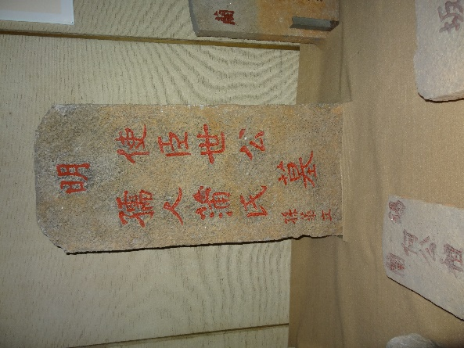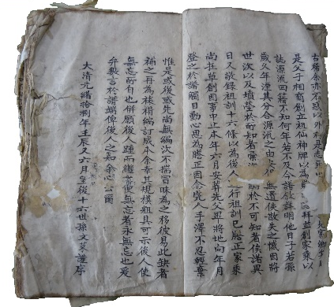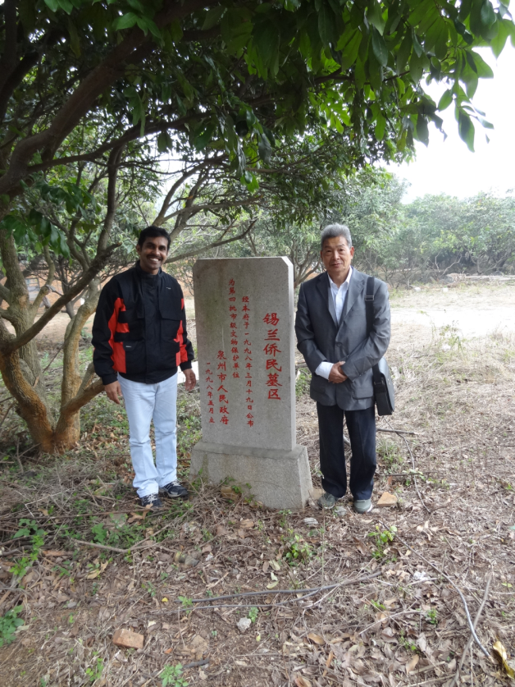
Tomb of Balaina Pedigree of Sri Clan Sri family cemetery-China

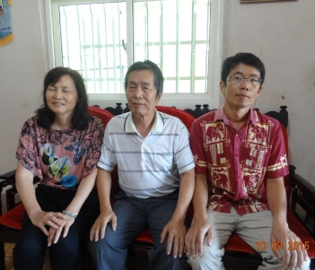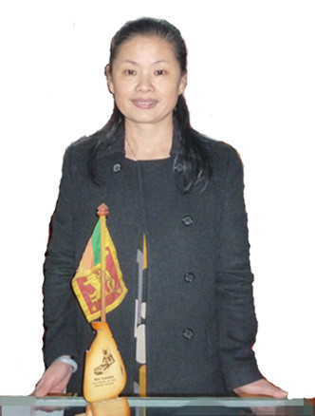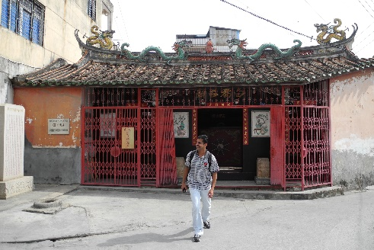
Sri Clan 19 and 20 genarations 19 genaration in China White dog temple-China
in Taiwan

Prof. Gamini Ranasinghe is a Professor of Archaeology and the former Director General of the Central Cultural Fund (CCF) at the University of Sri Jayewardenepura. He is a writer and public communicator with expertise in maritime archaeology. His current research focuses on the Sri Clan in China, Taiwan, and Sri Lanka, Heritage management and ethno archaeology.

