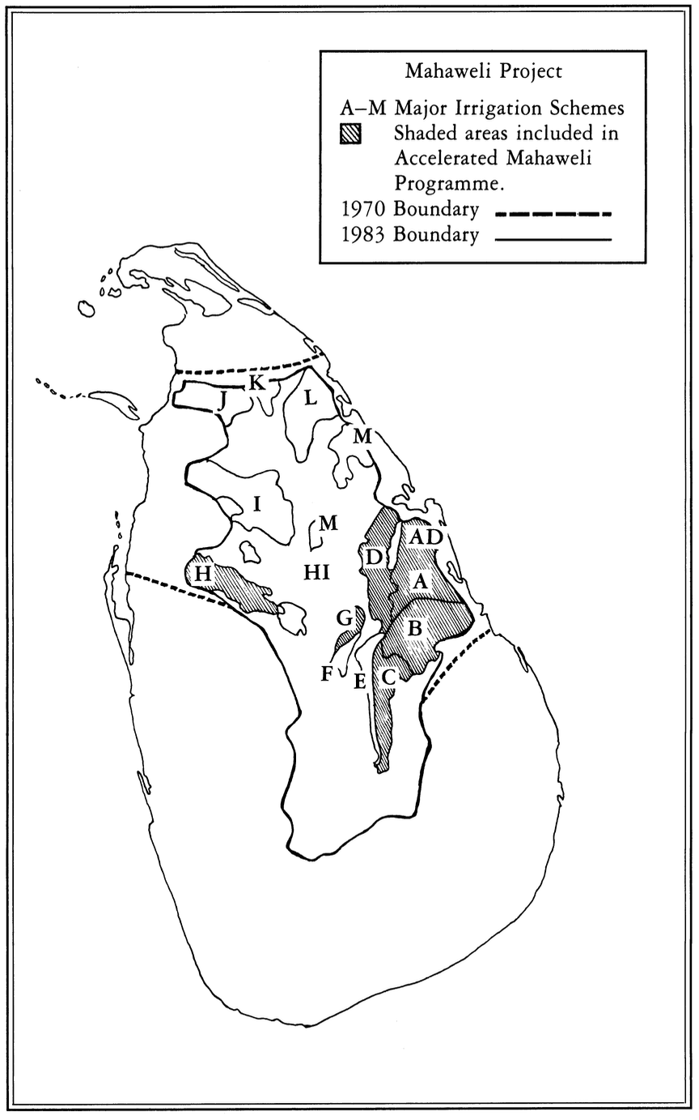
Map 2. The Mahaweli Project

