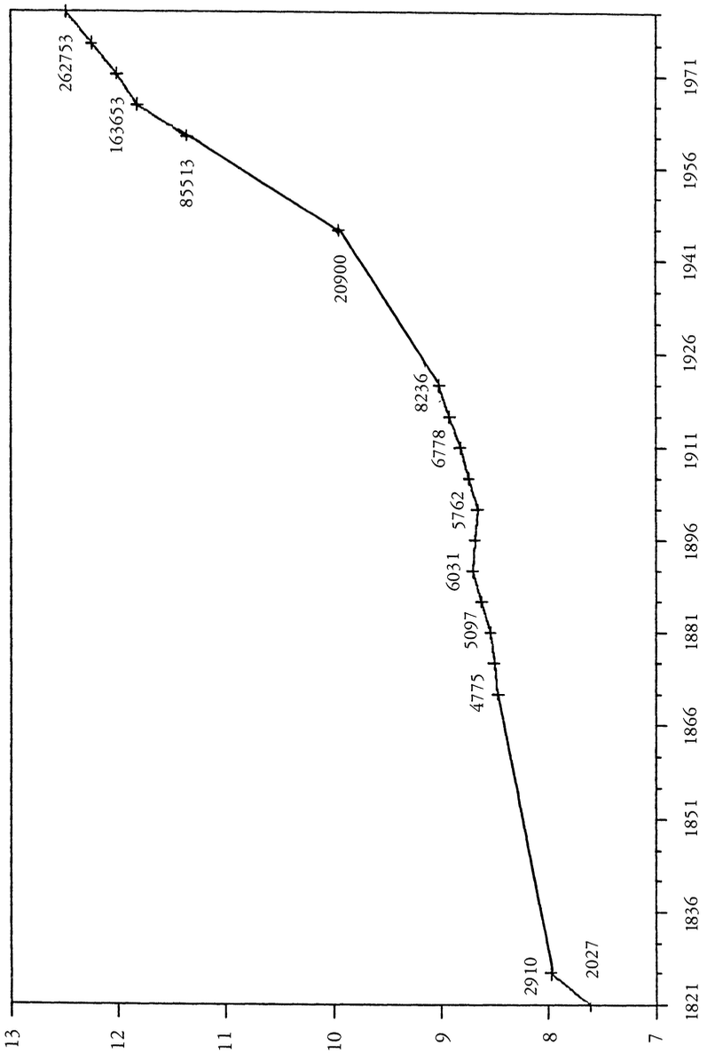

(Logarithmic Scale)

Fig. 1. The Population of Tamankaduwa, 1821-1981

