WISHING YOU
A HAPPY AND HOLY
CHRISTMAS
AND
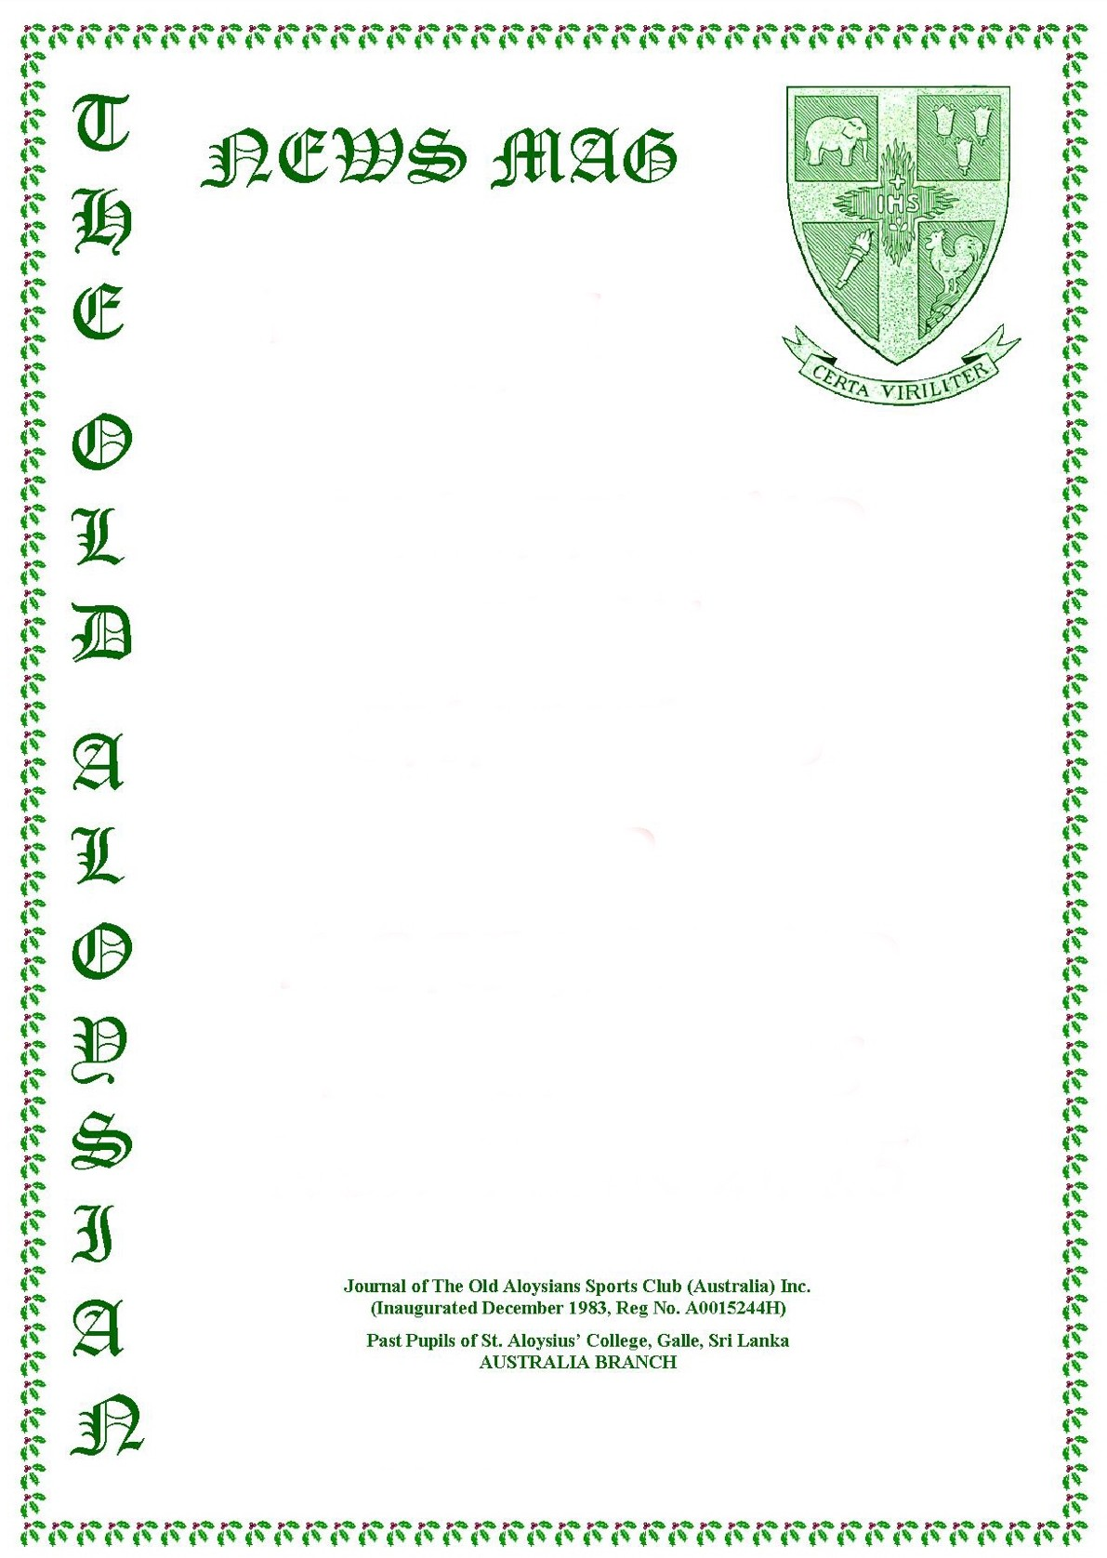
A BRIGHT AND PROSPEROUS NEW YEAR 2024

