https://thuppahis.com/2021/01/15/galle-cricket-grounds-tsunamied/
JANUARY 15, 2021 · 10:36 AM | EDIT
↓ Jump to Comments

Galle Cricket Grounds: Tsunamied……. !!!

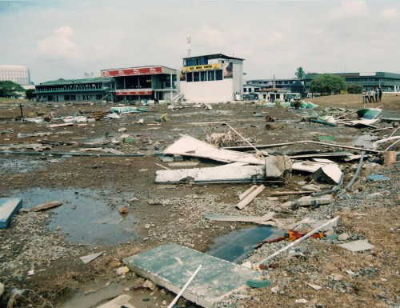
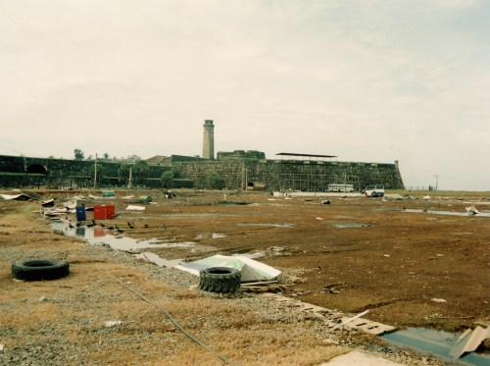
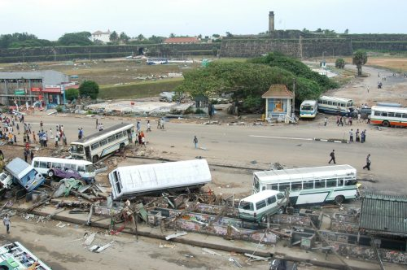

A VITAL NOTE
DIG THIS: “That is not the only moment when cricketing interests penetrate this work.[viz, Naseby’s Memoirs on his engagements with Sri Lanka –that Paradise Lost] During the tsunami relief work in the Maldives and Sri Lanka pursued so vigorously by Naseby and his doctor wife Ann, they had seen the devastation wrought on the picturesque cricket ground in front of the Fort at Galle. When Naseby returned to the island in early 2006, he brought a cheque for 50,000 British pounds from the MCC assigned for the restoration of the facilities at this spot. In effect, he scuttled the plans germinating in the mind of one Thilanga Sumathipala, wheeler-dealer extraordinaire, to build an entirely new stadium at some spot such as Habaraduwa – with all the benefits associated with the political and financial deals linked to such ventures.” — Michael Roberts in his review of the autobiography AT ……………………… …………….. ……. https://thuppahi.wordpress.com/2020/03/31/for-sri-lanka-engaging-lord-naseby-and-his-journeys-in-sri-lanka/

